

SRI LANKA INSTITUTE OF INFORMATION TECHNOLOGY

[**Enterprise Standards and Best Practices for IT Infrastructure**](http://courseweb.sliit.lk/course/view.php?id=137)

**4th Year 2nd Semester 2016**

Name: Samarakoon D.S.M.W.

SLIIT ID: IT13044732

Practical Session: WE

Practical Number : Lab 5

Date of Submission: 15.08.2016

**Lab 05 –** Creating a Virtual Machine on the Hypervisor

Creating a Virtual Machine on the Hypervisor

Step 01: Power on ESXi 5 from VMware Workstation.

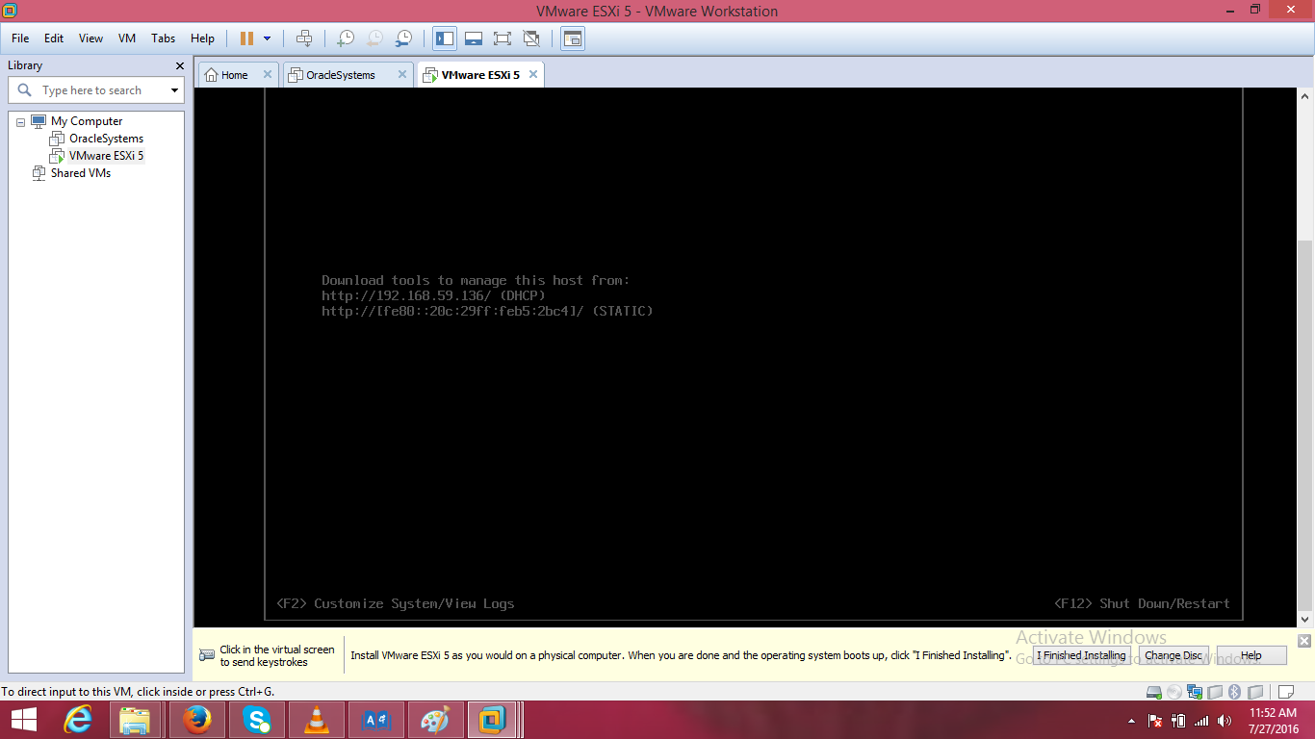

Step 02: Install VMware vSphere Client software and start it.

Provide the IP address of ESXi 5 host, the root username and password.

Click ‘Login’.

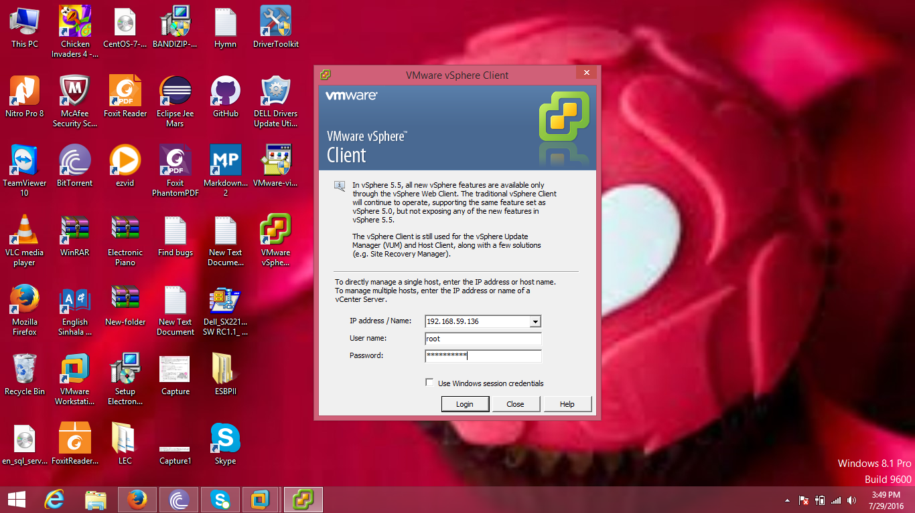

Step 03: Ignore the SSL certificate security warning.

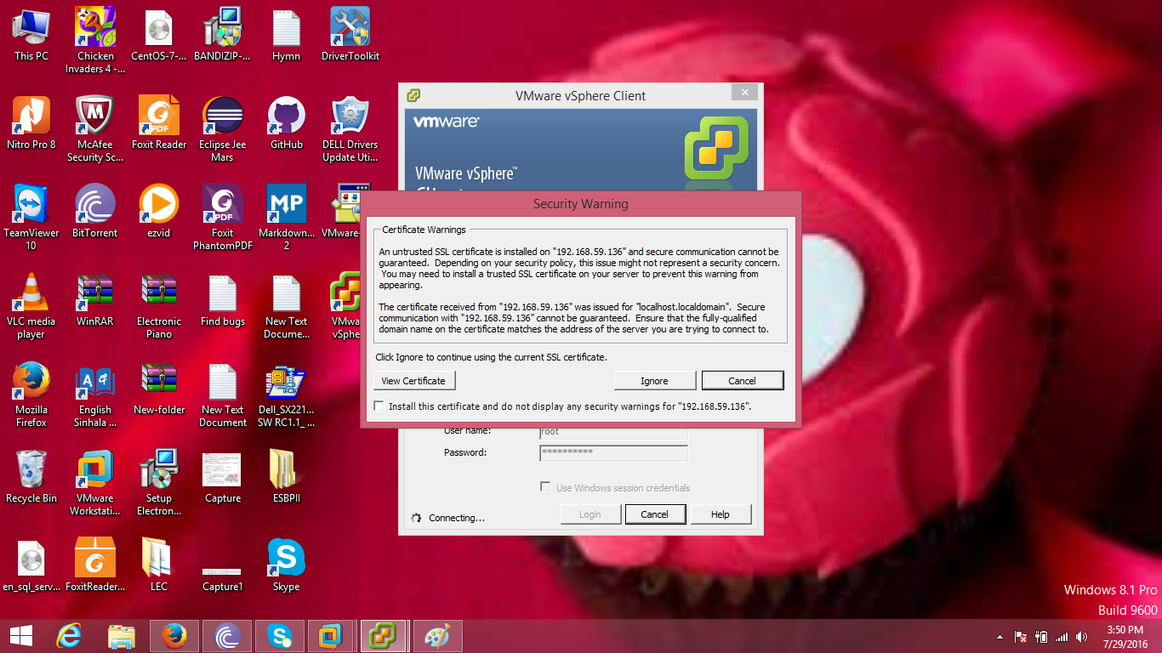

Step 04: Go to the ‘Summary’ tab.

Right click on ‘datastore1’ from ‘Storage’ category and choose ‘Browse Datastore...’

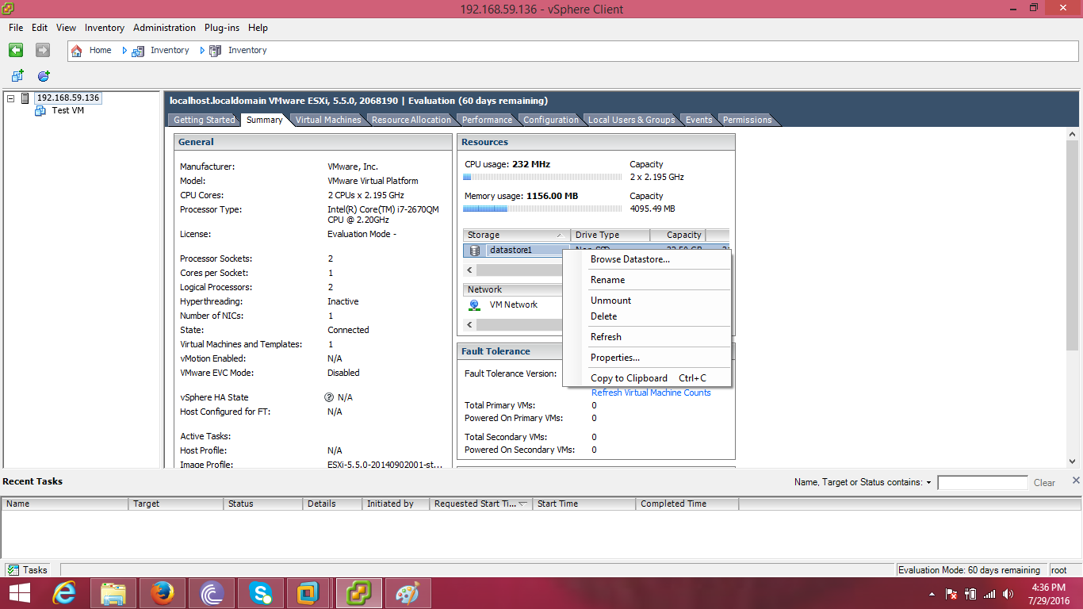

Step 05: Choose ‘Upload File’ from ‘Upload files to this datastore’ icon.

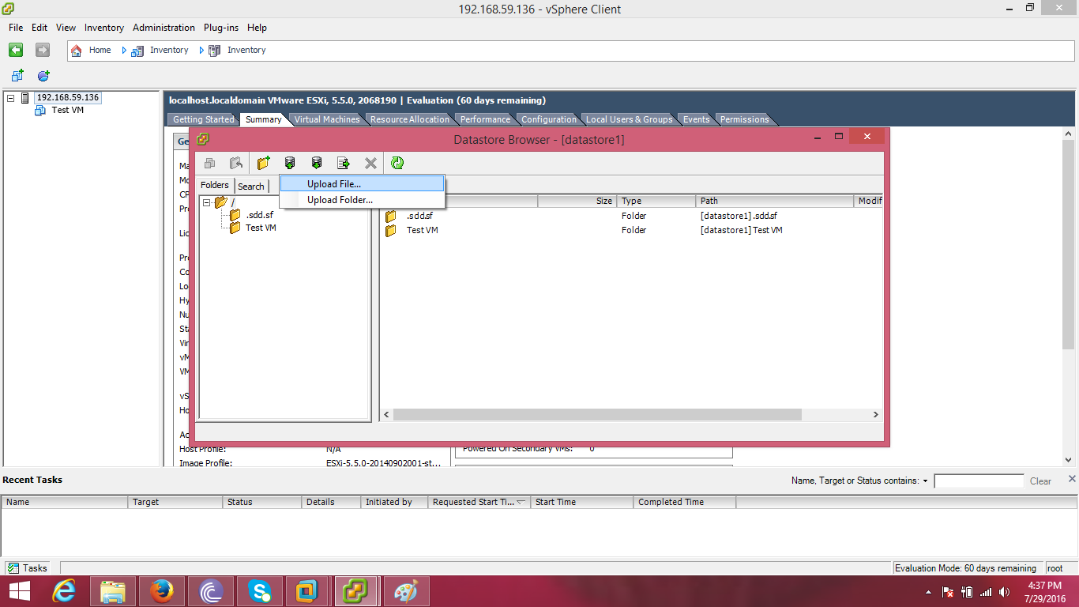

Step 06: Browse for the ISO file of an OS and open it.

Then close the window after uploading is finished.

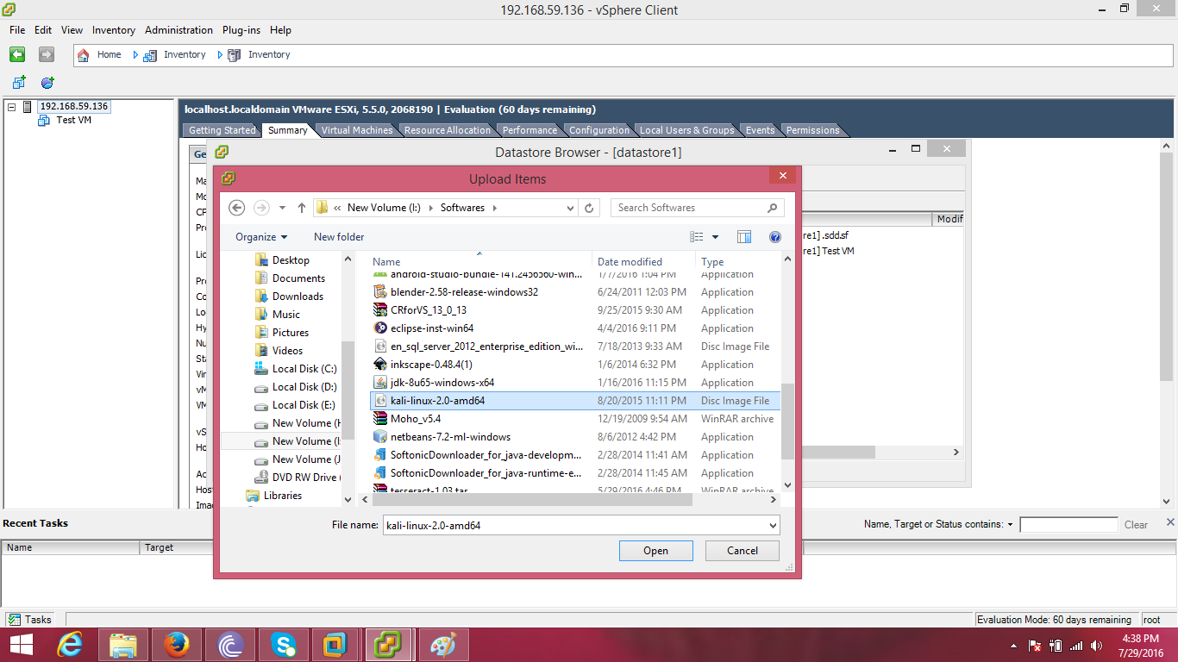

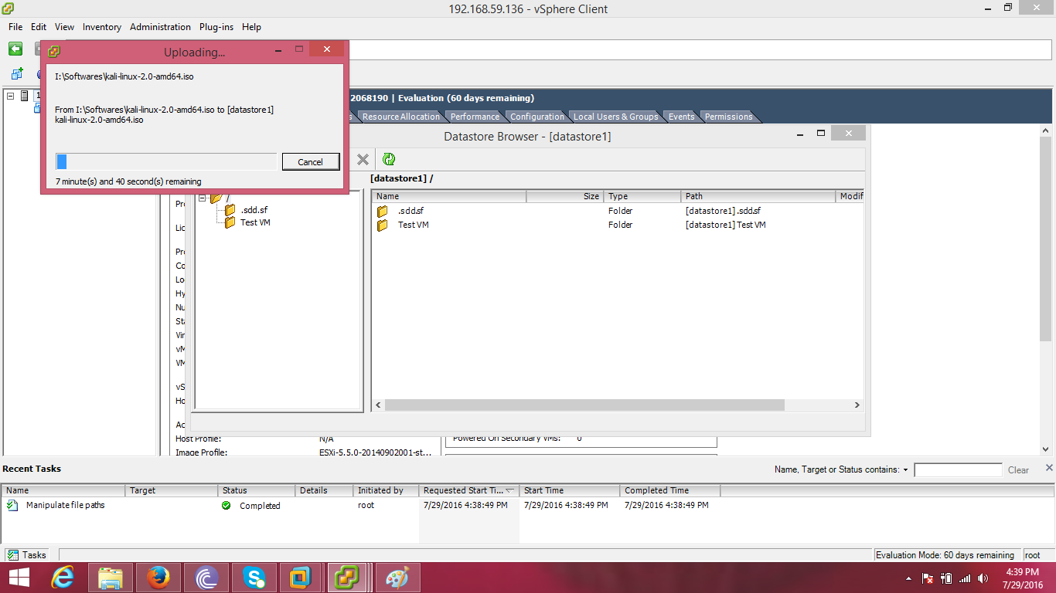

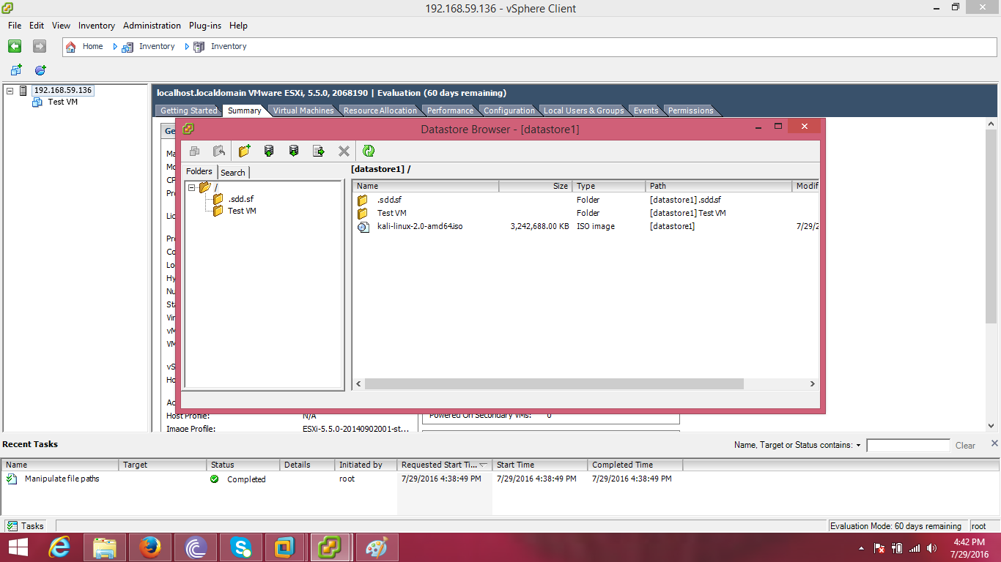

Step 07: Right click on the host and choose ‘New Virtual Machine’.

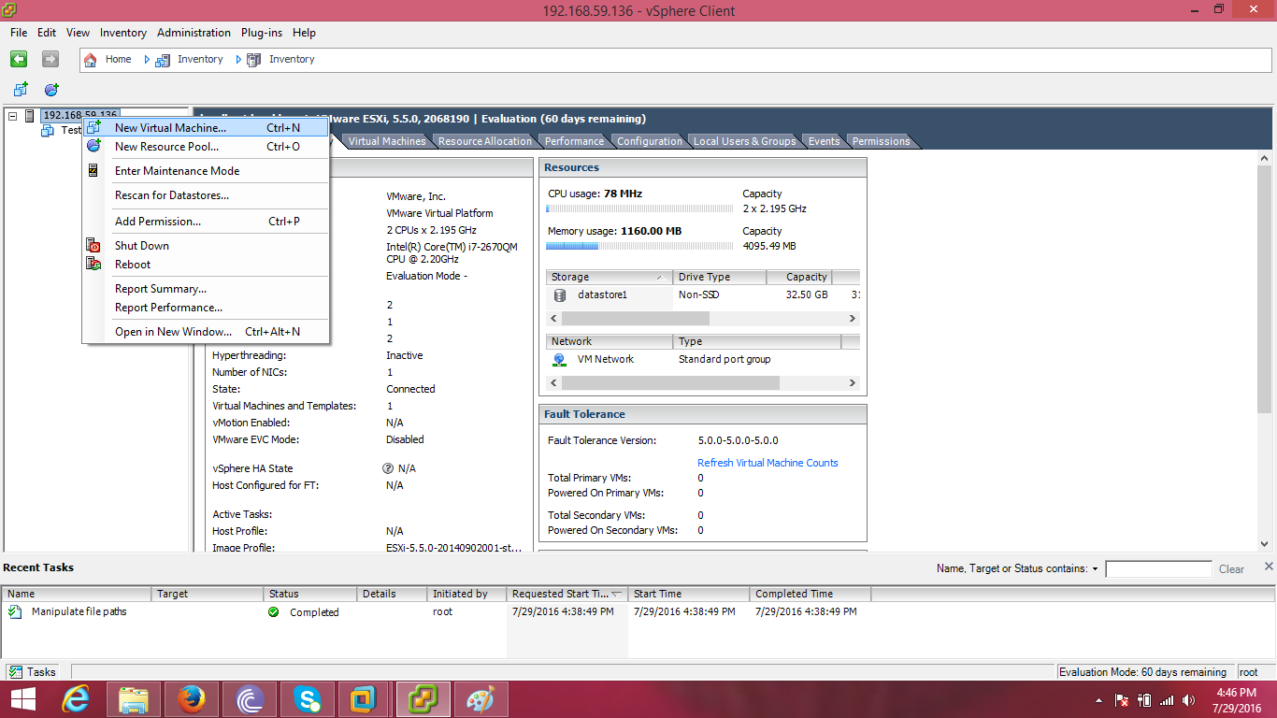

Step 08: Select ‘Typical’ under ‘Configuration’ and click ‘Next’.

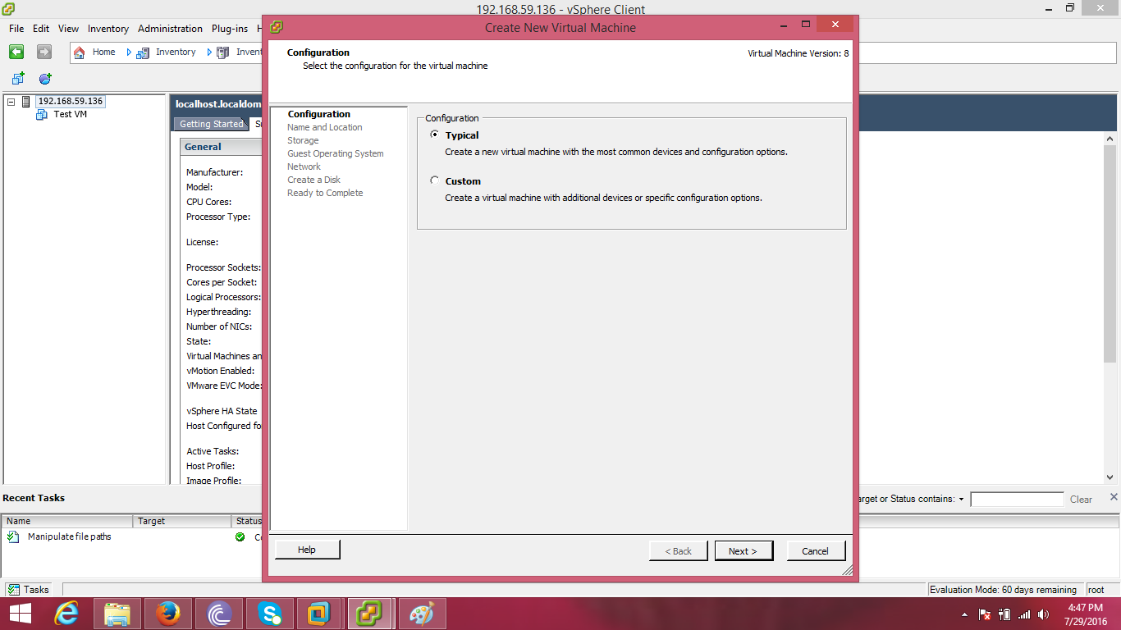

Step 09: Provide a name for the virtual machine and click ‘Next’. 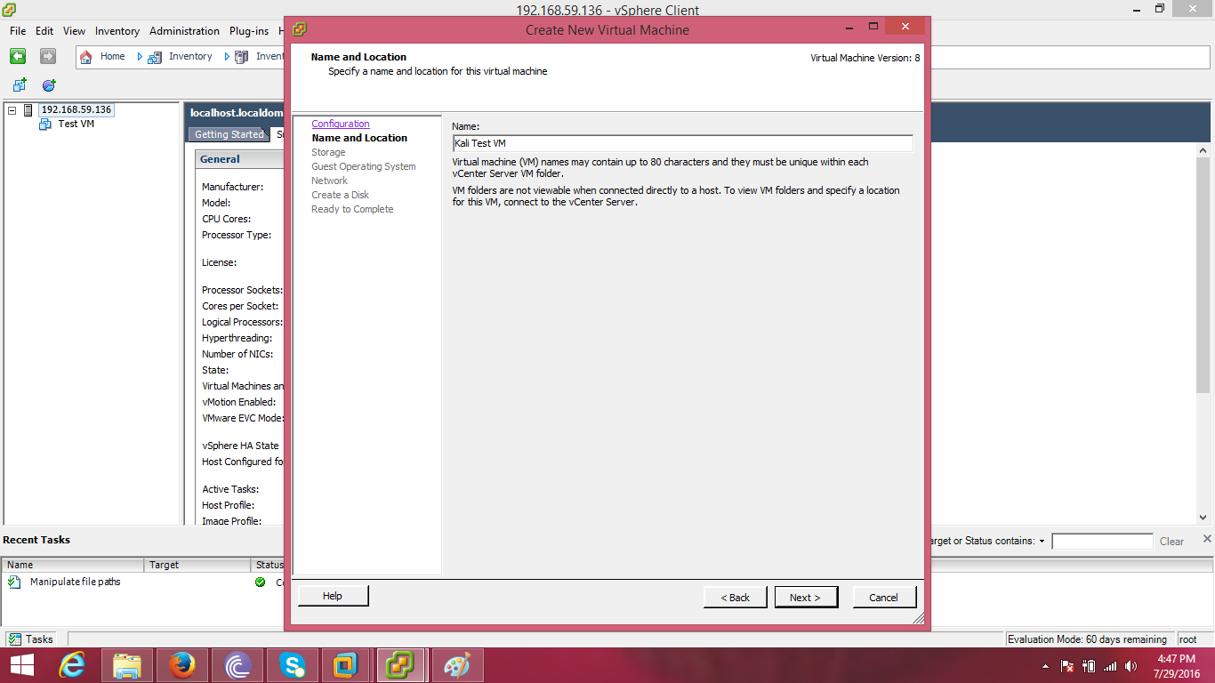

Step 10: Click ‘Next’ on ‘Storage’ section.

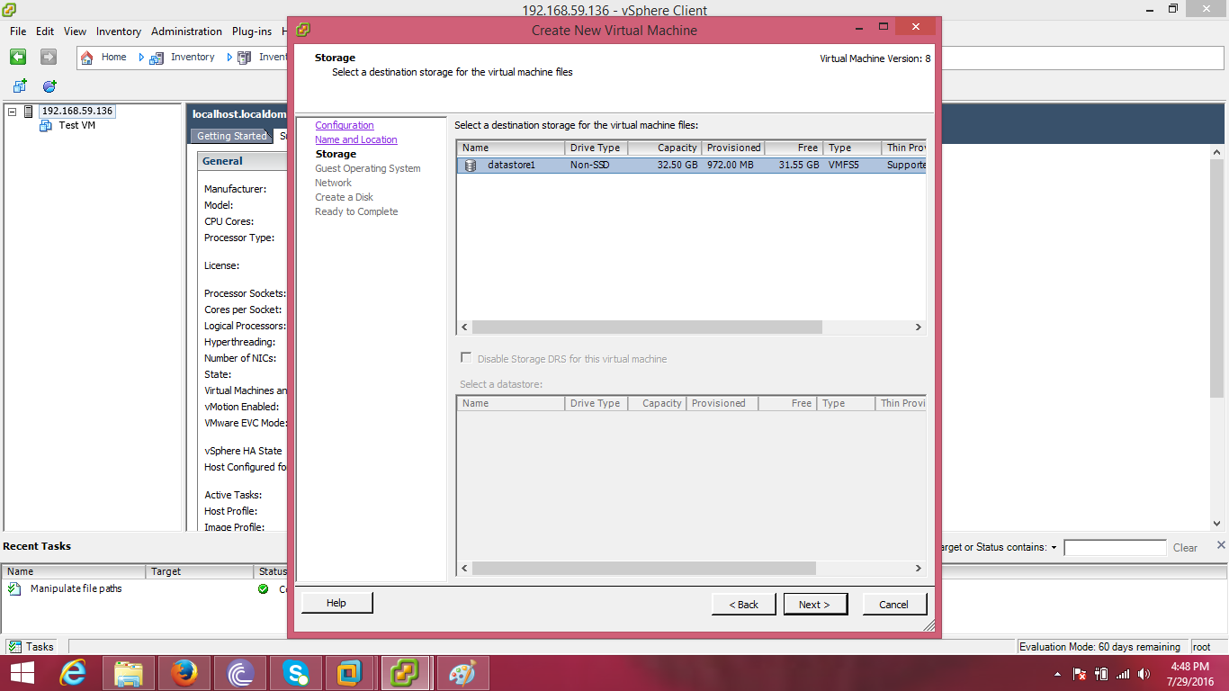

Step 11: Select ‘Linux’ under ‘Guest Operating System’.

Choose ‘Other Linux (64-bit)’ and click ‘Next’.

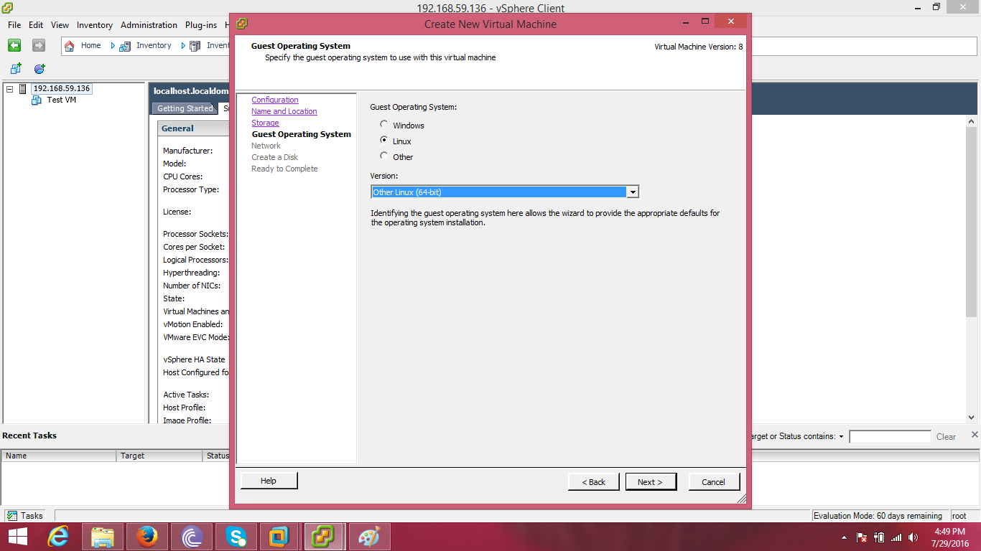

Step 12: Click ‘Next’ on ‘Network’ section.

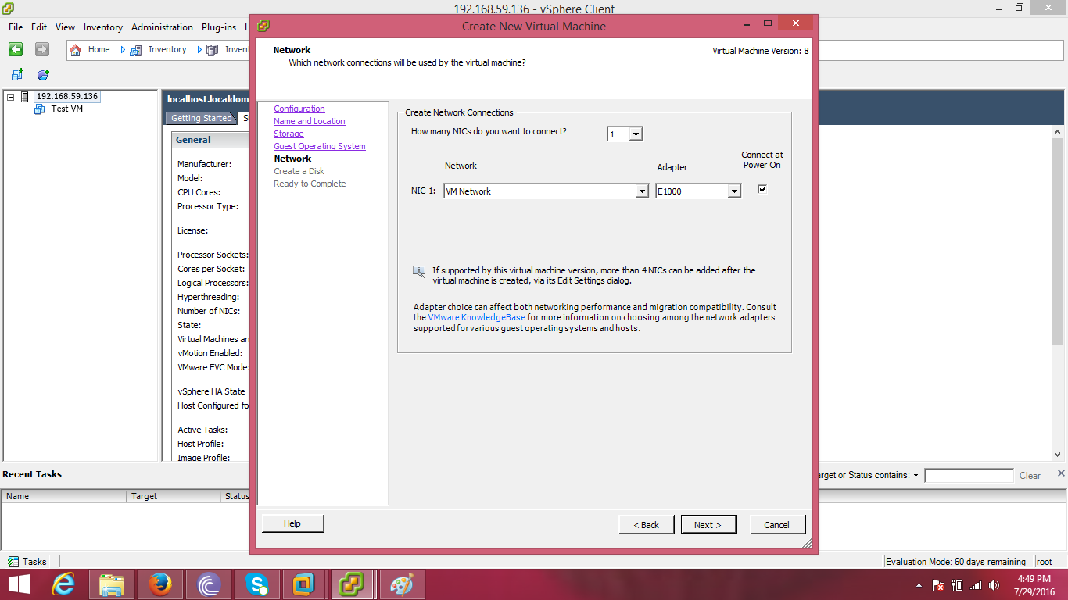

Step 13: Select ‘Thin Provision’ on ‘Create a Disk’ section and click ‘Next’.

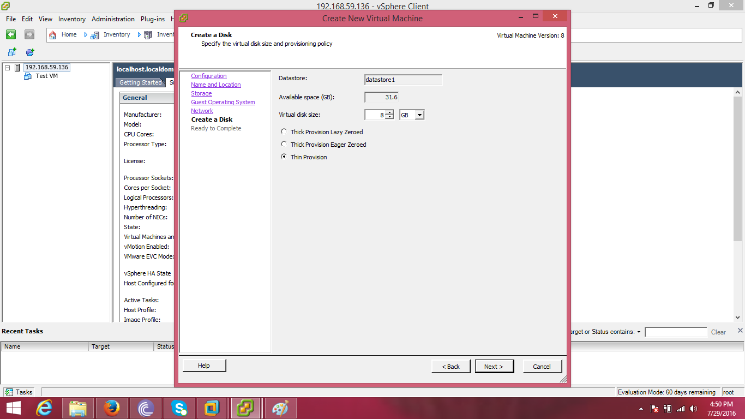

Step 14: Click ‘Finish’.

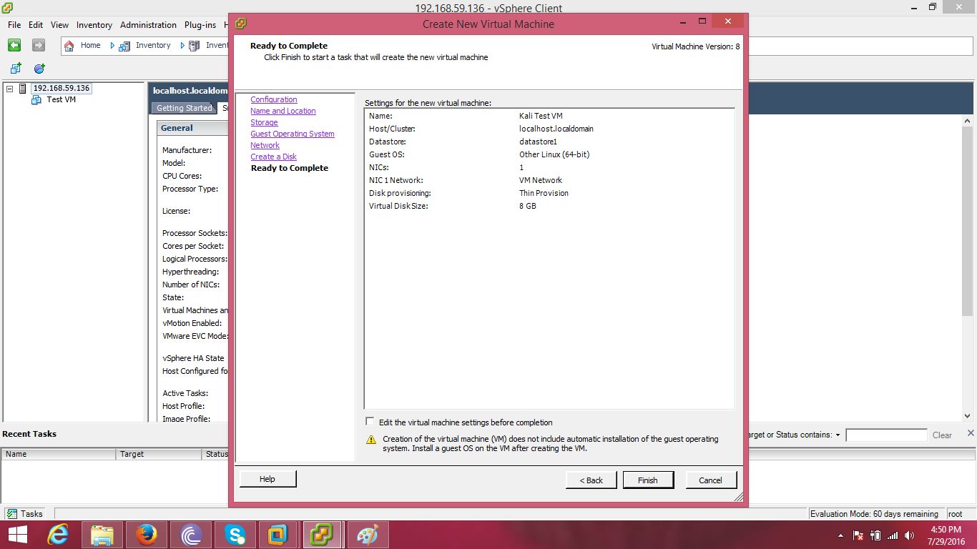

Step 15: Right click on the created virtual machine and choose ‘Edit Settings...’

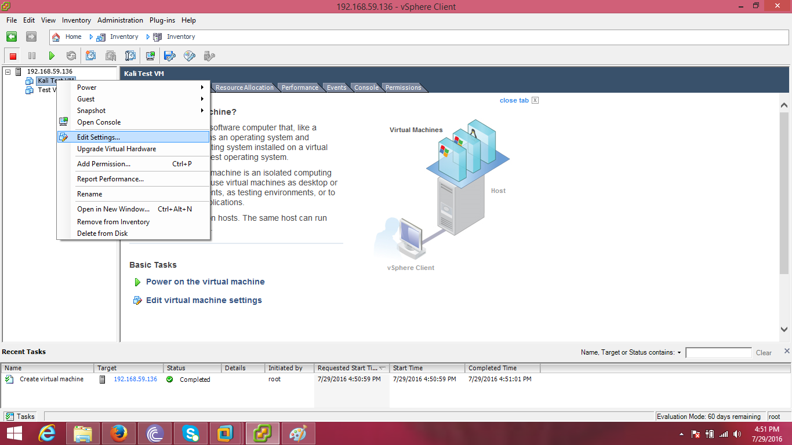

Step 16: Change the memory size to 2048 MB.

Select ‘CD/DVD drive 1’ and choose ‘Datastore ISO File’.

Browse for the ISO file from the datastore.

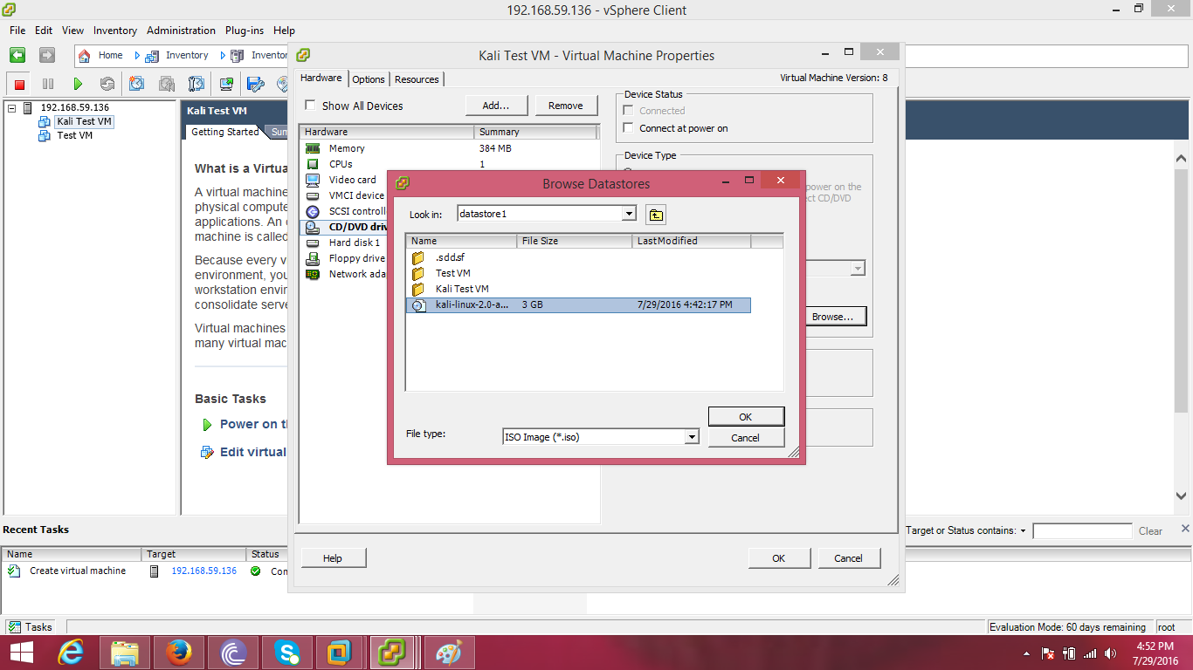

Step 17: Select ‘Connect at power on’ from ‘Device Status’, set the memory into 2GB and click ‘OK’.

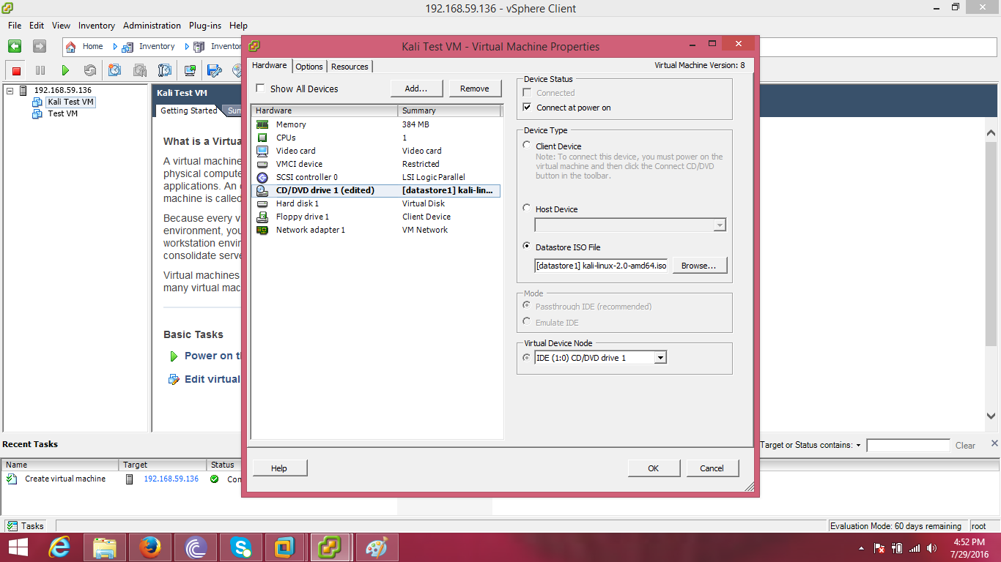

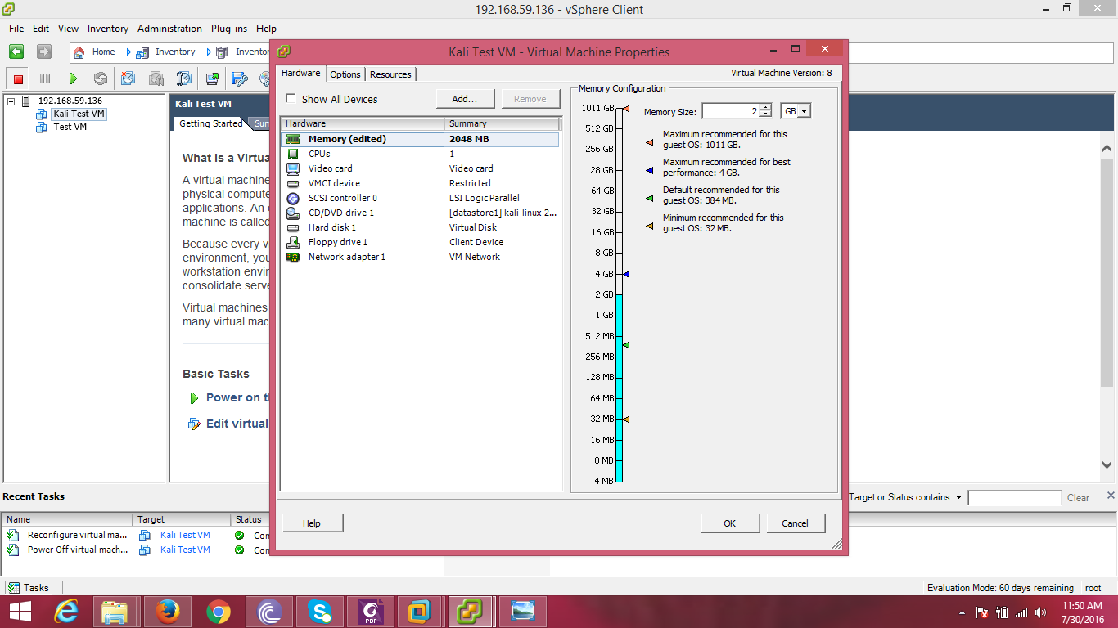

Step 18: Power on the virtual machine.

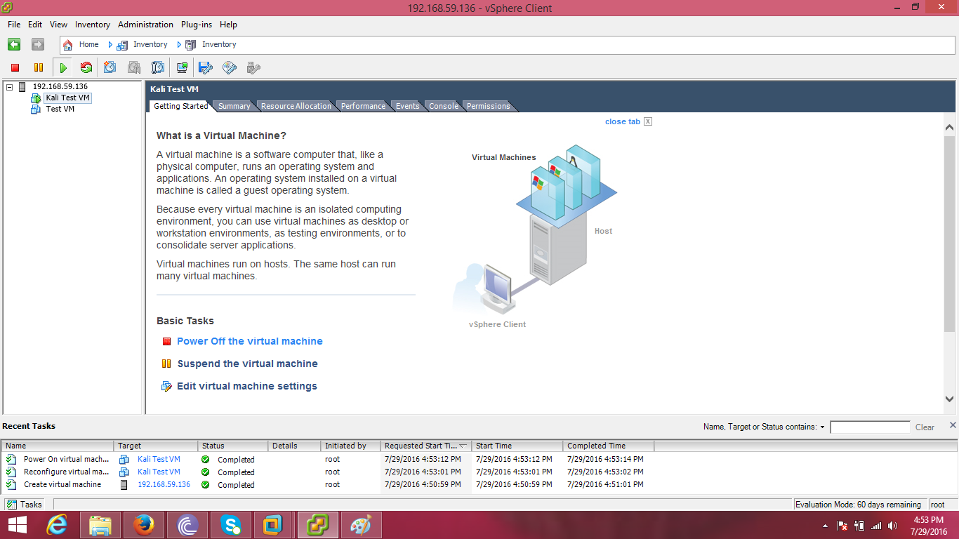

Step 19: Go to the ‘Console’ tab and choose ‘Live (amd64)’.

Press ‘Enter’ to start installing ‘Kali’ on the created virtual machine.

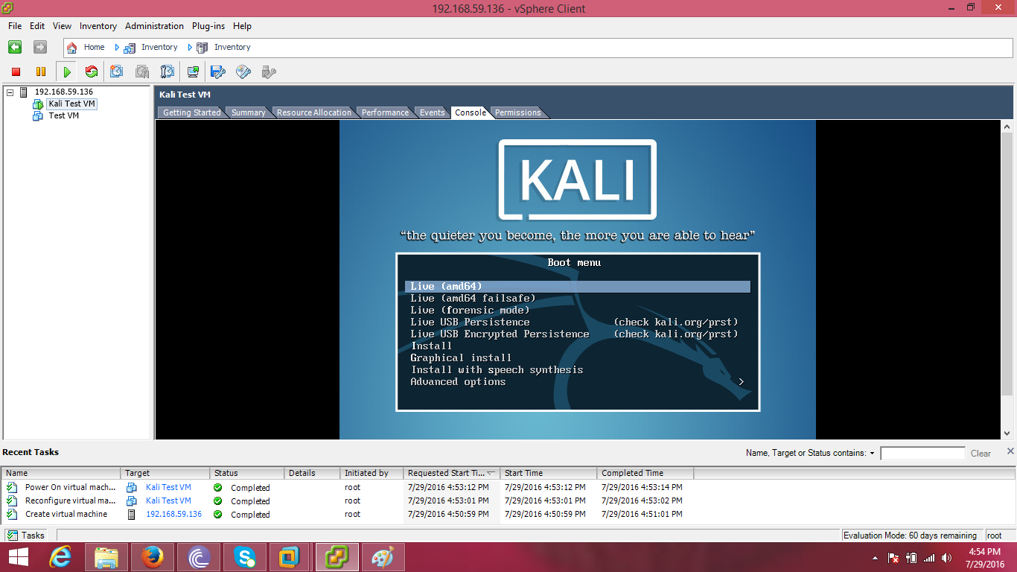

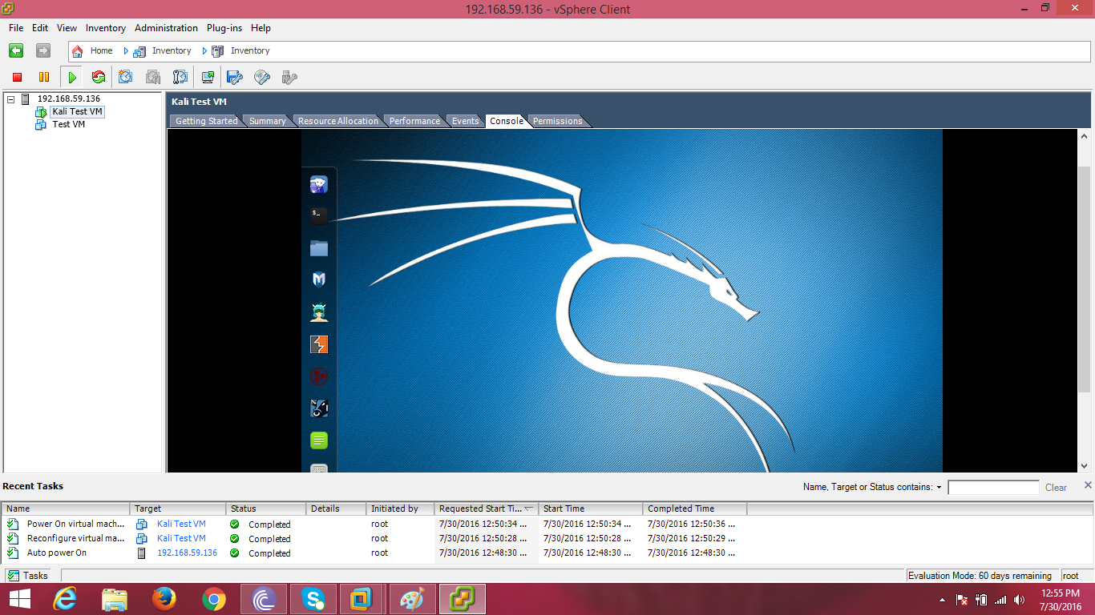

Step 20: Open the terminal and type commands to check functioning.

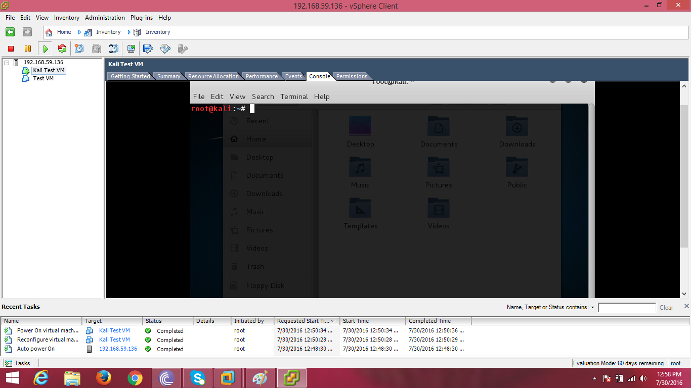

Step 21: Power off ‘Kali’.

Shut Down ‘ESXi’.

